IISER Bhopal Parts characterization (ECFP Coding Device) –
15 P - Kit plate 2

Step 1:- Extracting DNA out from the kit plate (15P).

Step 2:- Extracted DNA was transformed into DH5 Alpha cells.
Result:-
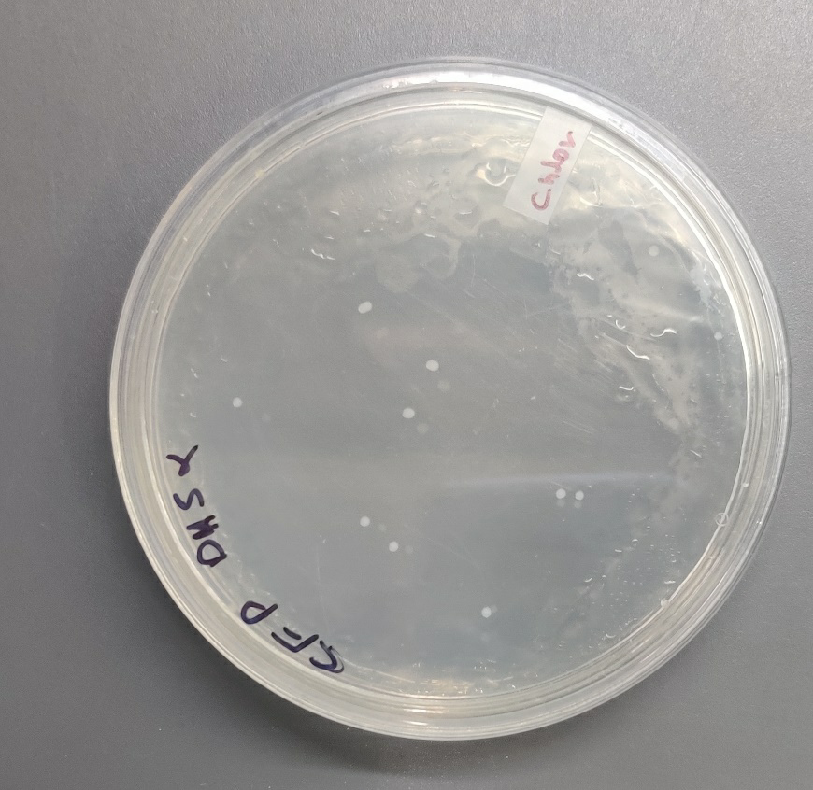

Step 3:- 10 ml of primary culture was grown using 1 isolated colony, and it was grown at 37 degree C for 12 hours.

Step 4:- Primary culture is divided into two parts, one is used for plasmid isolation and other is used for secondary culture.

Step 5:- 1 percent of primary culture is used to set the secondary culture in 3 (15 ml) falcons in 5 ml media and after approximately 2.5 hours when OD reached around 0.6, IPTG was added at different concentration, 0mM, 2mM, and 5mM. After that cultures were induced at 37 degree Celsius for 12 hours.
Step 6:-
2mM Culture was pelleted, supernatant was discarded. 20 uL 8M urea was added to the pellet, pellet was pipetted until it was dissolved. 5 uL protein loading dye (containing Beta mercap) was added to it. Sample was heated for 10 minutes at 80 degrees. Samples were run on SDS gel.

Results:
The following image was obtained in the gel doc. A dark prominent band was obtained around 25 kDa. The size of ECFP was 26kDa (literature survey).

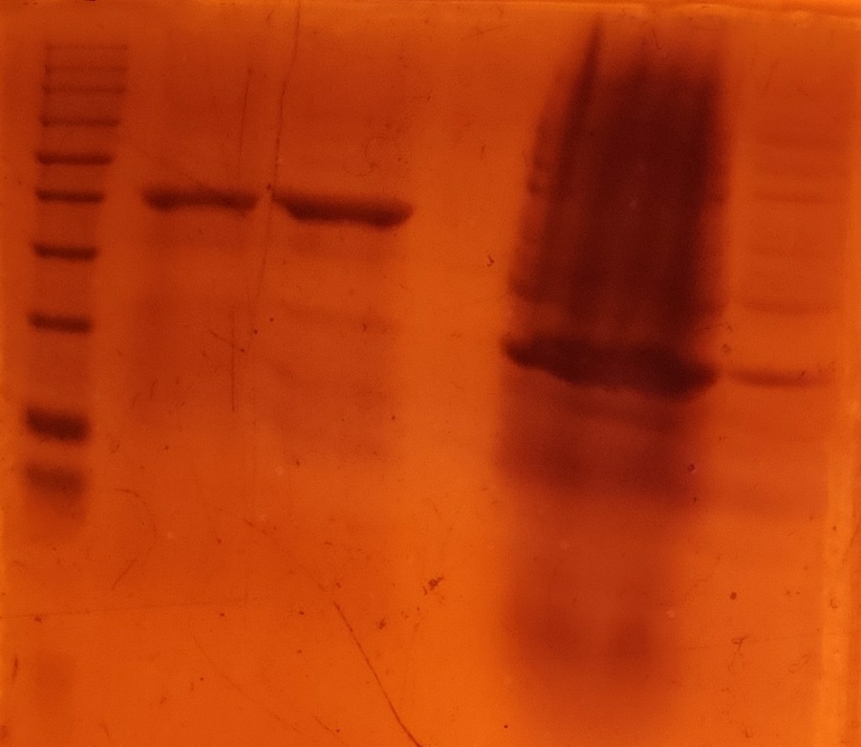
25kDa

Step 7:- Fluorescence was taken for three samples (LB media, 2mM, and 5mM).
Result: - No conclusive result, control is showing similar fluorescence as induced sample. Reason for fluorescence is due to LB auto fluorescence.

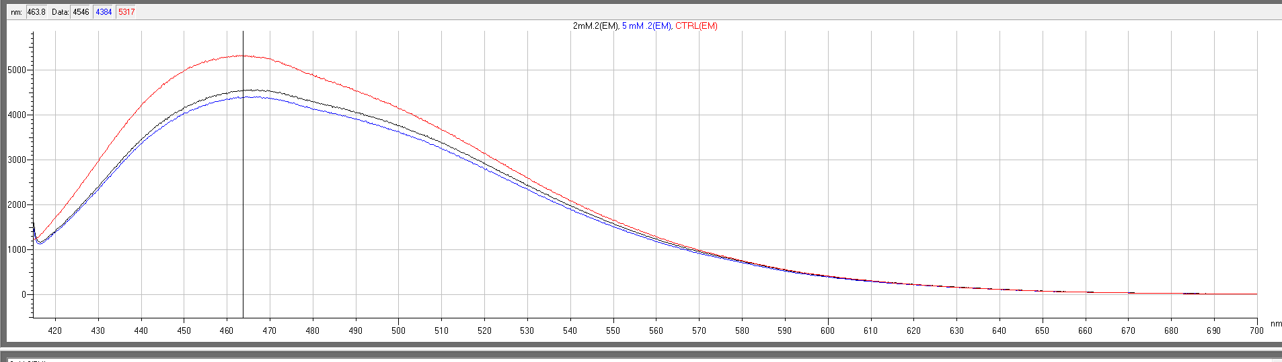
LB media (ctrl)
ECFP (IPTG – 2mM)
ECFP (IPTG – 5mM)

Step 8:- Protein isolation from cultures:
Materials: - Phosphate Buffer (20mM Sodium Phosphate, 50Mm Nacl), 8M Urea
Method: - Cultures were pelleted, supernatant was discarded. 200uL 8M urea was added to the pellet, pellet was pipetted until it was dissolved. 2 mL Phosphate buffer was added to it (make up the volume to level up for the fluorescence cuvette). Next step was to centrifuge it at 6500 rpm for 5 min. Now carefully pipette out the supernatant into a fresh MCT without disturbing the pellet
Step 9:- Fluorescence (0mM (ctrl), 2mM, and 5mM).
Result: - No conclusive result, control (0mM uninduced) show similar fluorescence as induced, and 5mM IPTG shows lower fluorescence than 2mM.
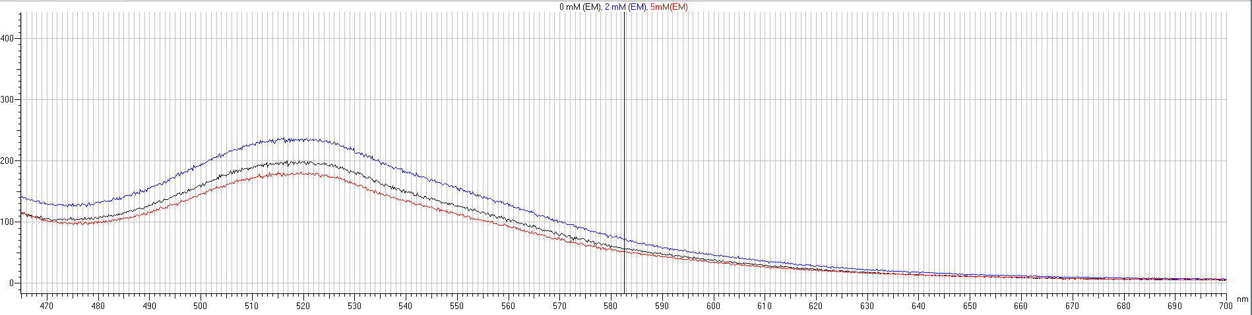
ECFP (IPTG – 5mM)
ECFP (IPTG – 0mM)
ECFP (IPTG – 2mM)

Step 10: -Since DH5 alpha cells are used as cloning strain we thought to repeat all steps in Expression strain BL21 (DE3) pLysS. It also contains a plasmid, pLysS, which carries the gene encoding T7 lysozyme. T7 lysozyme lowers the background expression level of target genes under the control of the T7 promoter but does not interfere with the level of expression achieved following induction by IPTG.

Step11:- 1 ul Plasmid isolated in Step4 were transformed in strain BL21 (DE3) pLysS.
Result:-
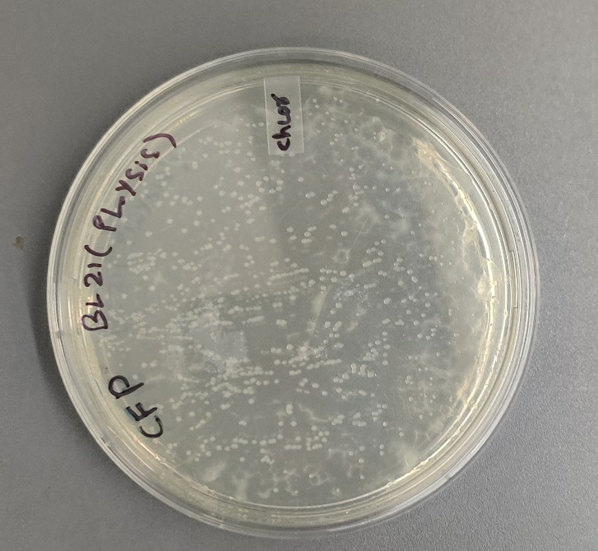

Step 12:- Primary culture of 5 ml using 1 isolated colonies, and let it grow at 37 degree C for 12 hours.

Step 13:- 1 percent of primary culture is used for secondary culture in 3 (15 ml falcons) in 5 ml media and after approximately 2.5 hours when OD reached around 0.6, IPTG was added at different concentration, 0mM, 3mM, 5mM. After that cultures were induced at 37 degree Celsius for 12 hours.

Step 14:- Protein was isolated using Step 8
Step 15:- Fluorescence was measured (0mM (ctrl), 3mM, and 5mM).
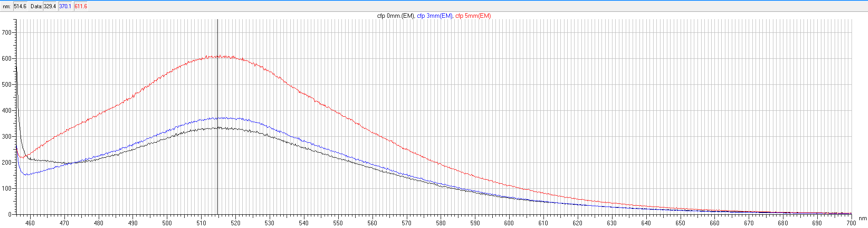
ECFP (IPTG – 5mM)
ECFP (IPTG – 0mM)
ECFP (IPTG – 3mM)

Result: - Correct pattern observed, control (0mM uninduced) show lower fluorescence in comparison to the induced culture, and 5mM IPTG shows highest fluorescence. But difference was not much.

Step 16:- Currently we are working on Expression strain BL21 Lemo21 (DE3) for clear result.

Step17:- 1 ul Plasmid isolated in Step4 were transformed in both strain.
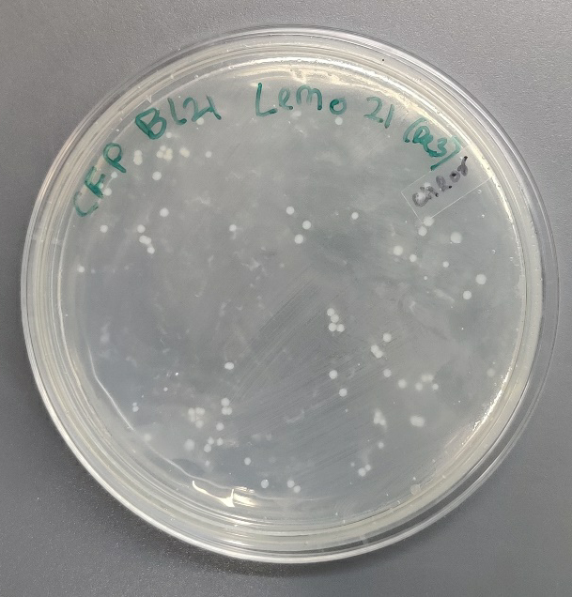

Step 18:- Primary culture of 5 ml using 1 isolated colonies, and let it grow at 37 degree C for 12 hours.

Step 19:- 1 percent of primary culture is used for secondary culture in 3 (15 ml falcons) in 5 ml media and after approximately 2.5 hours when OD reached around 0.6, IPTG was added at different concentration, 0mM, 2mM, 5mM. After that cultures were induced at 37 degree Celsius for 12 hours.

Step 20:- Protein was isolated using Step 8

Step 21:- Fluorescence was measured (0mM (ctrl), 2mM, and 5mM).

Result: -
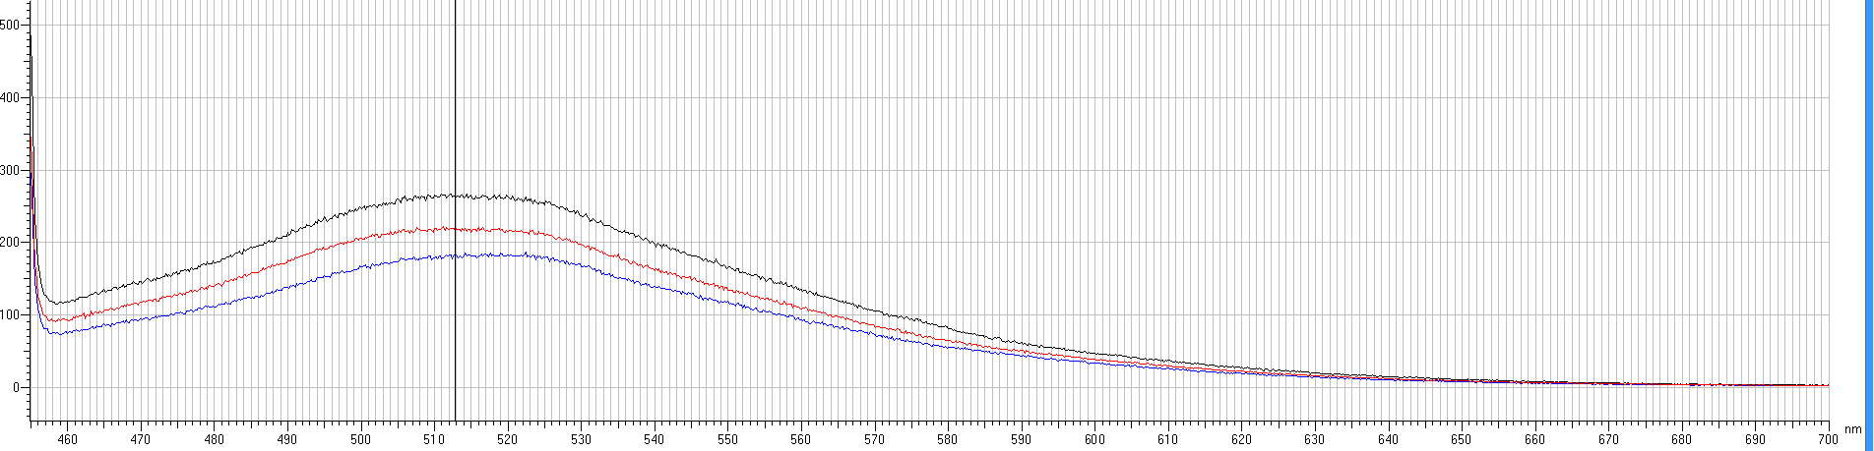
ECFP (IPTG – 0mM)
ECFP (IPTG – 2mM)
ECFP (IPTG – 5mM)

(Note:- For all the work (in plates, primary and secondary culture) antibiotic used is chloramphenicol.)

